**Project: ADV Job Portal**

2021

M Umer Mukhtiar (Leader) SP20-BSE-055 Usman Taufique SP20-BSE-046 Noor Ahmed SP20-BSE-049

**Object Oriented Software Engineering**

sp20-bse-055

## Proposal

## Introduction

An Advanced Job Portal or Recruitment App which enable the users to upload and manage their works and skills related to their field of interest and for the employment they seek for future. The managed profile or digital CV can be a real game changing for the people with skills and having no platform to showcase their skills and works related to field.

Recruitment App will give the Employers an easy way to recruit best members and employers for their organization or company, as this app provides them with the work details and proofs of their work in the required field.

Employers who are recruiting the candidates can access the profile and Documents of the user by opening the unique share link given by user to the employer.

The Total rating of the user or Employee will promote automatically with the system as by taking the overall feedbacks from the Employers who are reviewing the profile of candidate.

* **Modules of App:-**
* **User Management**

1. Register on App with Sign up Form.
2. After Sign up Login into the App with login credentials.
3. In case of Forgot Password a small system for password recovery by email with a friendly button.
4. Edit User Profile in App.

* **Dashboard or Contents Management**

1. Dashboard will have the complete overview of the User with Progress of Profile
2. The Documents section will be available in Dashboard
3. The Multimedia Items with their Upload option will be here.

* **Menu**

1. Overall main functionalities of portal are available there .
2. User can also view any other user profile through code shared by user.
3. Here also a search option for employees and employers with detail profile

* **Feedback Panel**

1. Employee and employer both are able to give feedback on each other profiles.
2. Here also a option of feedback for suggestions about adding skills ,adding functionalities etc.

## Vision and Business Case

We Aim to make an Advanced platform for the all the people out there looking for work and employment.

Job Portal will have Organized Dashboard and Inventory system to manage and analyze the progress of each Users.

* **Business Opportunity: -**

Finding a Job is a Difficulty for today’s generation. As the existing Job portals and Recruitment apps does not give much control to the user to fully share and showcase their skills, This project will vary in that department by making more information and multimedia to upload for employees and candidates for getting the best job according to the talent they have.

**Summary of System Features:-**

## Supplementary Specification

1. Each page shall open within 1 second of tap on button and upload process with low latency with server.
2. The profile of each user shall be confidential and safe in system by his/her password and email.
3. The user demanding to increase storage space shall be given a monthly plan to upgrade their storage in system.
4. System shall be low end friendly which means it can be opened on any low end devices
5. The system will not damage or lose data of user if a crash happens as it operates with real time saving environment.
6. User shall not wait too long for a file to upload or download a file from server.
7. System shall not exceed the maximum storage provided to user for uploading documents and images.
8. User shall get a welcome message and a tutorial guide for the use of website after logging in to the system.
9. The website shall load in less than 2 seconds if the users profile’s data is less than 100Mbs.

## Risk List & Risk Management Plan

***Describes the risks (business, technical, resource, schedule) and ideas for their mitigation or response.***

**Risk List :**

* Usage of fake documents by employees.
* Copyright Issue on Shared content.
* Using Abusive Language in feedback .
* Privacy and security issues.
* Duplication of account.
* Inappropriate Feedback .
* Identification of scammers flash fraud.
* **Risk Management Plan :**

Accounts are verified by admins and in case of using fake documents and giving wrong information account should be banned by Admins. And After hiring or taking interview from any employee through portal Employer have option to give feedback against the employee hired from portal and if user have not fair feedbacks against their profile in that case profile is also banned .And user have also an option to give their feedback against employer profile and their company. And if any user can use abusive language in feedback account should be temporary ban and filters are used in backend to stop or put that feedback on pending until reviewed by admin and if someone try to spam in feedback account will be temporary ban and use of multimedia is allowed if user have permission and copyrights or have any proof that confirms content belongs to user directly or indirectly and one email or phone number will be used only for one account Duplication of account is not allowed.. And content user want to share with employer will be visible between user and employer and make sure data will be able to open through pin or system generated code .

**Project Prototypes**

* **User Management (SP20-BSE-055)**

**Login Section:**

<https://ibb.co/f21qz4d>

**Forgot Password:-**

<https://ibb.co/D4TW6hc>

**Sign Up :**

<https://ibb.co/9grC6rJ>

* **Menu**

**Menu:**

<https://ibb.co/khD8R9f>

------------------------------------------------------------------------------

## Contents Management(SP20-BSE-046)

### Dashboard Home and Overview:

<https://ibb.co/8xLrpXR>

### Documents Section:

<https://www.iloveimg.com/download/1d92vwc9t6jnkyvx1wb1Aph1A5c8j3x66mcmv5k0g5g2l8sr9t816dkk9Alvfd7t1dv43428r7rt974s9vk1v745zfr7zlywfvyb5t7vpyvn31hpq7rvAd037zcvn2kj2t5q0A1lgvczdc6clpq3nxlqy5zjn1yns79v2fqjrp727zrvxh6q/8>

### Videos Links:

<https://www.iloveimg.com/download/qtfjxrsmryj2qc9vq9rg235nl4vfjjvl64y9xbd0qsf5z2byh63w1nd9q7vt6nm988j0xbsh3s3l7xtjq3kgvzsvz30c22Aq5b5vbn2sjwdf28rlhltwps0pkzd5dmznmprd9r9fjlrbAkwb6mvx0pnd9km9qA5r0pnq6m3x35m82pq911fq/5>

------------------------------------------------------------------------------

* **Feedback Panel** (SP20-BSE-049)

**Select Category:**

<https://www.iloveimg.com/download/6j4Aslb01cA018q1dkfqzkj43v4fk13hw1j2xb9kkjr2x85bhx6d2d71q8A2p5rbjktnklbdlmfc9c0ds12qb6hArsyk6knkjr4Av54kbcmkb11159859lgdgndA9h5dbq5dcr2snl17ym6xjnlxkbpnA7pl6bjy59yw32c8ymAbc7xf8pAq/1>

**Give Feedback**:

<https://www.iloveimg.com/download/c38y8bk1wdhzsk9jwlj066ltnxzqk9jqc8rc6xk6rq51n0tt1p2b4sz9ygrv80qf08v003pz7qrr9730d4gmq1r9f08jlx45gy2pr9480gAt503c5nAv6yrqx18dnyys4nz2sn9cj4cjv88jg8h2q3sd1xcv6d9qlA2xc9f867d4tAzstyg1/8>

**Use Case Diagram:-**

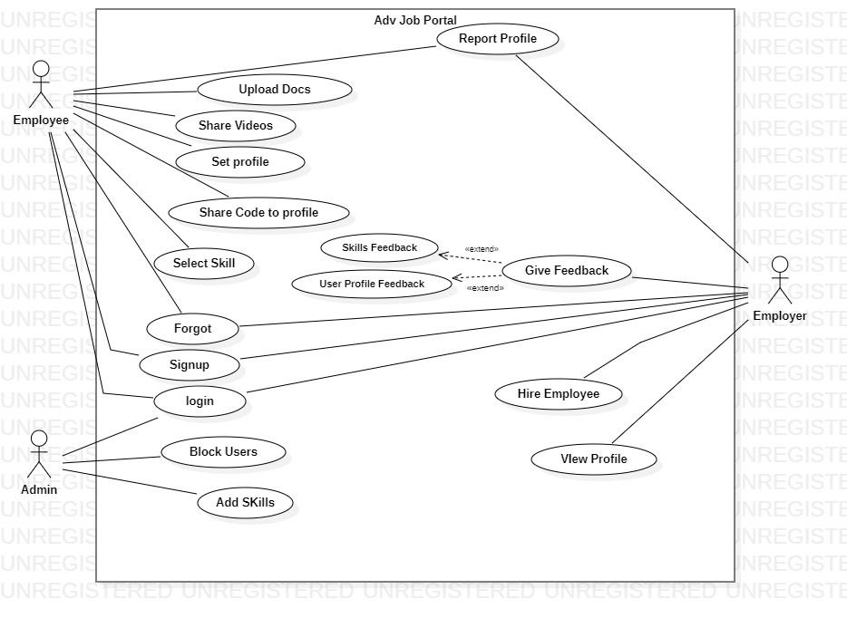

**Domain Model**

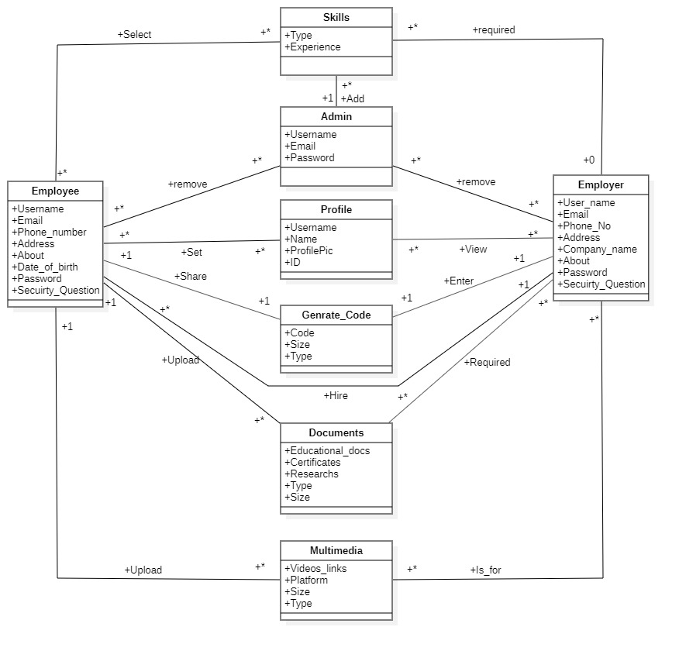

**Class Diagram**

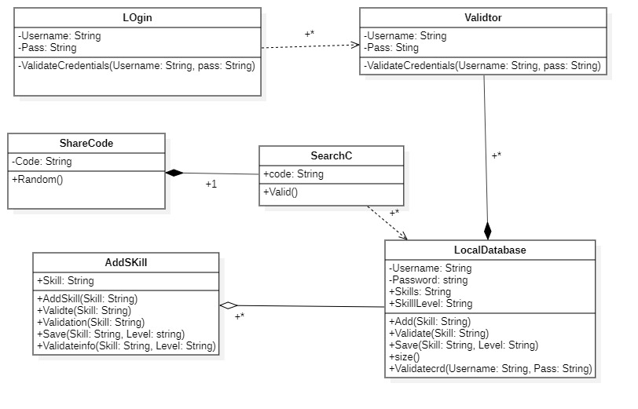

**Primary Actors of Project:-**

1. **Employee/Candidate**
2. **Admin**
3. **Employer**

**Goals of Primary Actors:-**

**Candidate:-**

1. Login **(SP20-BSE-055)**
2. Signup **(SP20-BSE-055)**
3. Forgot Password **(SP20-BSE-055)**
4. Upload docs **(SP20-BSE-046)**
5. Upload Media Files**(SP20-BSE-046)**
6. Set Profile **(SP20-BSE-055)**
7. Share code to Profile**(SP20-BSE-046)**
8. Select Skills **(SP20-BSE-055)**
9. Report Profile **(SP20-BSE-049**)

**Admin:-**

1. Login **(SP20-BSE-055)**
2. Block User **(SP20-BSE-049**)
3. Add Skills **(SP20-BSE-055)**

**Employer:-**

1. Login **(SP20-BSE-055)**
2. Signup **(SP20-BSE-055)**
3. Forgot Password **(SP20-BSE-055)**
4. Skill Feedback **(SP20-BSE-049**)
5. User Profile Feedback **(SP20-BSE-049**)
6. Set Profile **(SP20-BSE-055)**
7. View Profile **(SP20-BSE-046)**
8. Hire Employee **(SP20-BSE-055)**
9. Report Profile **(SP20-BSE-049**)

**Brief Level:- (Muhammad Umer Mukhtiar SP20-BSE-055)**

**1.Signup:-** Open App simply Go on the Login page and select the option of Signup and put correct information in empty fields . And some of text fields are compulsory to be filled and also be agree on terms and conditions by clicking on agree After accepting terms and conditions click on Signup And your account is created and user name and password will be previewed on screen.

**2.Forgot Password**:- User open the app and click on the Forgot password button and empty text field is appeared and Enter email or user name click on submit and security question is appeared answer that and after that user directly linked to the manage profile window to set their password again.

**3.Login:-**User open the app and login session was created and window appears at user end and ask for login Information(Username, password) in empty text fields and after filling text fields click on Login button and you’re greet with Dashboard Window.

**4.Set Profile:-** User open Portal greet with Login Screen And Fill the text fields with required information and click on login button and greet with Dashboard and select the option of set profile and from Here users can change their name and user can also change password and select new skills from here and also will be able to add bio data itself and after making changes simply click on save Changes.

**5.Add Skills:-**login to portal and go to Add skill and select the skills from combo box and also add new skills in profile by using text filed also select expert level in given skills and after adding skills click on save changes. Skills are previewed on user profile.

**6.Hire Employee:-** login to portal and click on menu and write required skill at search bar and click on button all relevant user having employer required skill are shown at below the menu and from here user can click on user name profile should be appear in front of employer from here employer can click on select option to hire user .

**Brief Level:- (Usman Taufique SP20-BSE-046)**

**1.Upload Document:-** A Candidate or user log ins to system and is provided with skills manage by admin and after completing profile User is given a Upload documents section, The user enters the location or path to the document and its format which are according to system needs and then system validates and shows the document on the profile of User.

**2.Generate Code:-** User Opens the profile menu and generate code button sends the system to link generation service and a random link is generated with URL and sharing option to other social media and copy to clipboard (Link is expired after 2 mins of generation).

**3.Upload Media:-**Candidate has option to paste the link to the videos of him/her working materials and real experiences on the App. Link to the video with valid streaming platform can be shared on the Portal with Name.

**4.View Profile:-**Employers who want to hire or review a working candidate for some job or company can view his/her profile with pasting the share code given by Candidate and pasting it on the portal.

**Brief Level(SP20-BSE-049)**

**1.GIVING Profile FEEDBACK:-**Frist of all the employer will click the feedback section and enter the section. Then he will See the four columns. The first section is to write the overall feedback in second section he can write the unique skills of employee and then the third section will for the best skills of and then he can rate the user profile in fourth section and then he will click the submit button of feedback and we will use the filter in feedback section if someone uses the abusive language he cannot give feedback

**2.Report profile:-** First of all the employee will enter the feedback and then he has to click on the sub button of report . then he will write the username of the his profile and then in the other column he has to enter the profile user name on which he is going to report after that he has to write the report or issue that is in that report and then he has to submit the report after that is the system allows the report and passes through the filter and submitted

3.**GIVING FEEDBACK TO SKILLS:-**First of all the employer will click the feedback section and enter the section. Then he will See the four columns. The first section is to write the skills feedback in second section he can write the unique skills of employee and then the third section will for the best skills of and then he can rate the user profile in fourth section and then he will click the submit button of feedback and we will use the filter in feedback section if someone uses the abusive language he cannot give feedback

_________________________________________________________________

**Fully Dressed :-**

**Login** (**Muhammad Umer Mukhtiar SP20-BSE-055)**

**Scope:-** Job Portal App

**Level:-** User Goal

**Primary Actor:-** Employee ,Employer , Admin

**Stakeholders and Interest:-**

-**Employee**:- Have Account to login.

**-Employer :-**Have Account to login.

-**Admin**:-Have Account to Login.

**Preconditions:-** open portal and enter login information .

**Success Guaranteed(Post):**- Login Session created And User Logged In Successfully.

**Success Scenario (Flow of events):-**

* Open Portal.
* Login Session created
* Enter Email or User Name
* Enter Password
* Click on Login.
* Dashboard tab will be opened

**Extensions(Alternative flows):-**

* If User do unnecessary tries for Login and password account will be temporary banned
* If User enter wrong email or user name system show dialog box with message to Enter Correct User Name and Password

**Special Requirements:-**

* Text fields
* Background colors
* Buttons

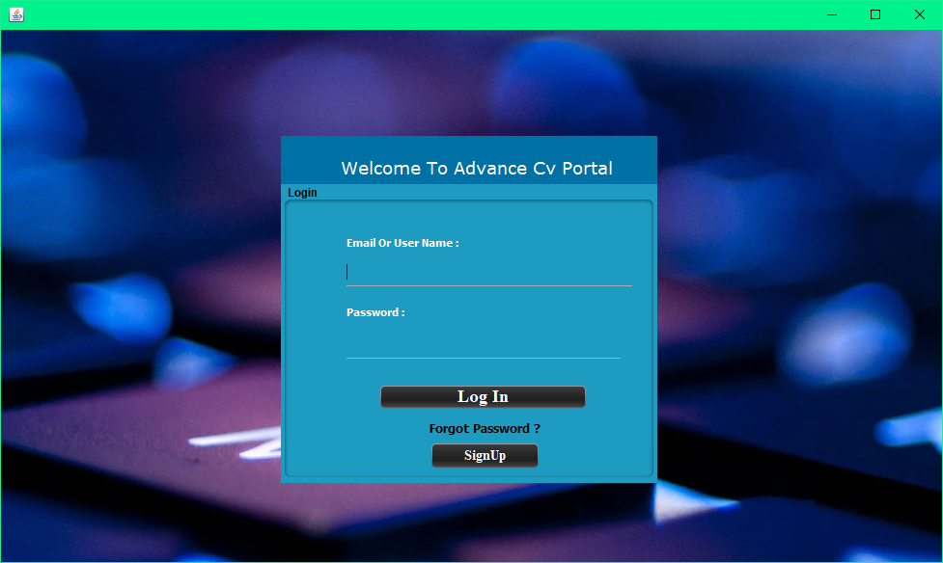

**Set Profile** (**Muhammad Umer Mukhtiar SP20-BSE-055)**

**Scope:-** Job Portal App

**Level:-** User Goal

**Primary Actor:-** Employee ,Employer

**Stakeholders and Interest:-**

-**Employee**:- Have Account to Set Profile and add more information to show more attractive view of profile.

**-Employer :-**Have Account to Set Profile and share info about required work.

**Preconditions:-**

give required Information in text Fields select options from combo boxes(Education , skills, country code) and upload profile picture .

**Success Guaranteed(Post):**-

Save changes Successfully and Profile Updated.

**Success Scenario(Flow of events):-**

1. User Login
2. Greet with Dashboard.
3. Go to Menu
4. Click on Set Profile
5. Enter Required information in Text fields
6. Select right options from combo boxes
7. Click on upload profile
8. Select picture and Upload
9. Click on save changes
10. Changes are applied on profile successfully

**Extensions(Alternative flows):-**

* In case of giving wrong information or try to use fake name or less than 10 digit number dialog box appeared with warning
* user do not give bio red text is appeared in text area.
* user does not select country code dialog box will be appeared with warning
* user do not select any skill dialog box appeared with warning
* user select more than 1 pic profile picture could not be changed.
* any other format file or pic selected like pdf, docx etc. profile pic will not be changed
* mandatory fields are empty dialog box appeared with message.

**Special Requirements:-**

* Text fields
* Background colors
* Text area
* Buttons
* Combo boxes

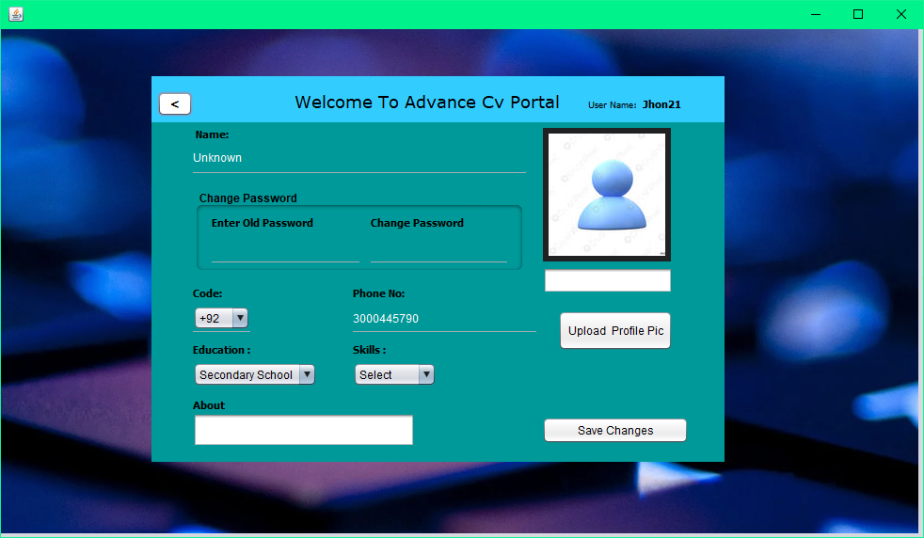**Sign Up** (Muhammad Umer Mukhtiar SP20-BSE-055)

**Scope:-** Job Portal App

**Level:-** User Goal

**Primary Actor:-** Employee

**Stakeholders and Interest:-**

-**Employer**:- It is necessary to create an account to use the portal.

-**Employee**:- It is necessary to create an account to use the portal for hiring employees.

-**App**:- Application requires the information to approve the account to register

**Preconditions:-**. Candidate will be required to give the information in order to create register account and maintain a public profile.

**Success Guaranteed(Post):**- After giving information it will be updated to user profile and will be save on public server .

**Main Success Scenario(Flow of events):-**

1. Open Portal
2. Click on Signup
3. System Greets with Signup Window
4. User fill the required fields
5. Select the required options
6. Accept terms And Conditions
7. Click on Submit .

**Extensions(Alternative flows):-**

* If user want to use single email for multiple accounts dialog box will be shown with warning
* In case user given name is already existed suggestions of names will be shown
* If user not accept terms and conditions submit button will be disabled until user agree to terms and conditions
* In case User miss to filled the mandatory text fields. Process could not be go forward and show red text in text fields until they will be filled

**Special Requirements:-**

* Background Color
* 8 digit Password
* E-mail
* Accepting Terms and conditions.

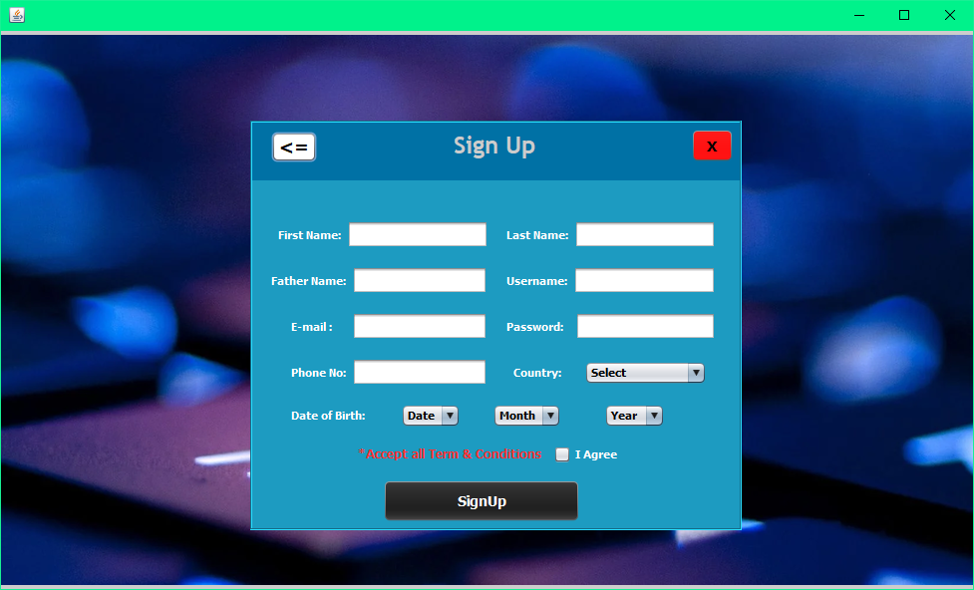

**Add Skills** (Muhammad Umer Mukhtiar SP20-BSE-055)

**Scope:-** Job Portal App

**Level:-** User Goal

**Primary Actor:-** User

**Stakeholders and Interest:-**

-**User**:- Add skills to profile making more attractive profile and easily .

**Preconditions:-** select skills from combo box or add skills through text field.

**Success Guaranteed(Post):**- Save changes Successfully and skills will be Updated on profile successfully.

**Main Success Scenario(Flow of events):-**

1. User Login
2. Greet with Dashboard
3. Go to add skills
4. Select Skills from combo box
5. Add more skills by using text field
6. Click on save changes
7. Save Changes Successfully

**Extensions(Alternative flows):-**

-> user do not select any skill dialog box is appeared with message

-> already existed skill couldn’t be added again.

**Special Requirements:-**

* Ui
* Skills
* Buttons
* Combo boxes

**Operation Contract**

* **Operation Contract for Add Skill**

|  |  |
| --- | --- |
| Contract Id | ADDSkill(Skill) |
| operation | **AddSkill(skill);** |
| Cross Reference | **Add Skill** |
| Pre-Condition | **Select Skills from combo box**  **Add new skill by text field** |
| Post Condition | * **Saved in database** * **Validate(skill) by validator** * **Save against user profile** * **Ready to be previewed against profile** |

2021

|  |  |
| --- | --- |
| Contract Id | Select level() |
| opreation | **SelectLevel()** |
| Cross refrence | **Add skill** |
| Precondition | **Select level from combo box** |
| Post condition | * **Save expert level against skill.** * **Added to Database against profile** * **Assign level on Portal** |

* **UI**

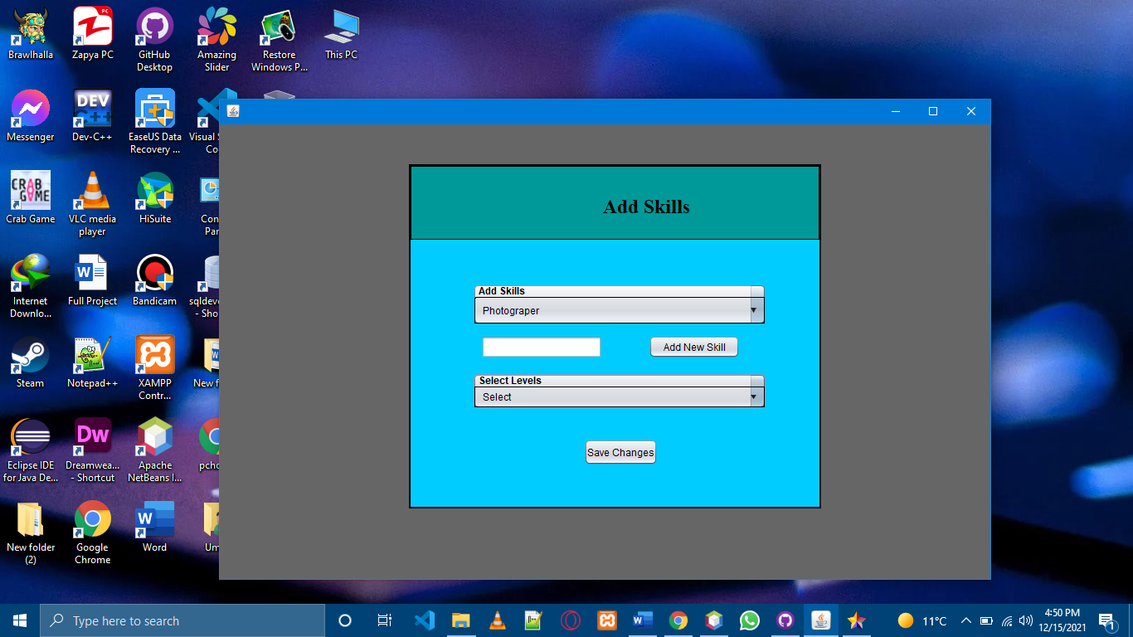

* **SSD**

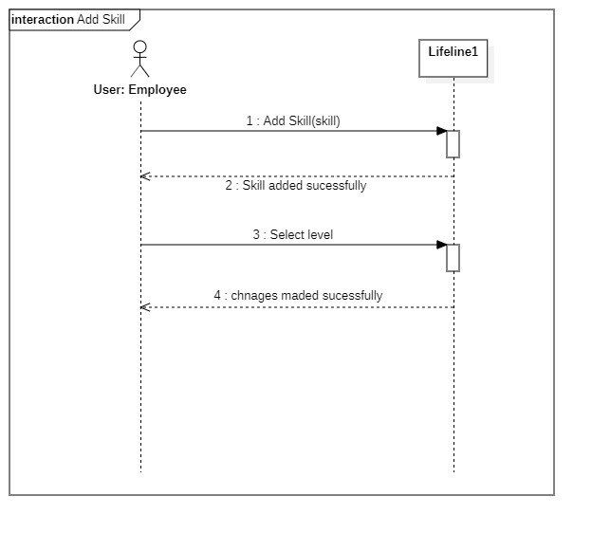

* **Communication Diagram**

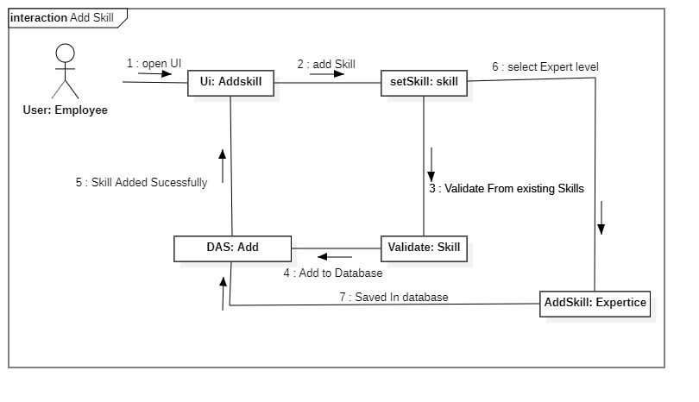

* **Sequence Diagram**

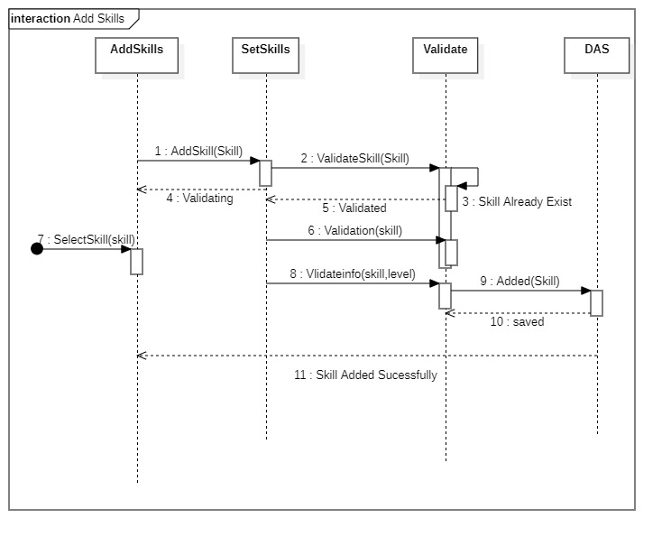

**Forgot Password**(**Muhammad Umer Mukhtiar SP20-BSE-055)**

**Scope:-** Job Portal App

**Level:-** User Goal

**Primary Actor:-** Employee

**Stakeholders and Interest:-**

-**Employee**:- have user name or email to forgot password.

-**Admin**:- admin will temporary block users who will try to use of forgot password option to much.

**Preconditions:-**. User enter Username or email to forgot password.

**Success Guaranteed(Post):**- User is logged in and is informed that account password was successfully changed

**Main Success Scenario(Flow of events):-**

1. Open Portal
2. Go to Login
3. Click on forgot password
4. Enter Email or User Name
5. Answer Security Question
6. Click On Submit
7. Manage profile tab will be opened
8. Now enter your New Password
9. The system notifies user that the
10. password was successfully change.

**Extensions(Alternative flows):-**

* user do unnecessary tries for forgot password account will be temporary banned
* text field was empty enter email message will be previewed
* user answer was wrong account will be disabled
* User enter wrong email or user name system show dialog box with message to Enter Correct User Name and Password
* password is less than 8 digits password will not be changed

**Special Requirements:-**

* Text fields
* Buttons
* Labels
* Frames

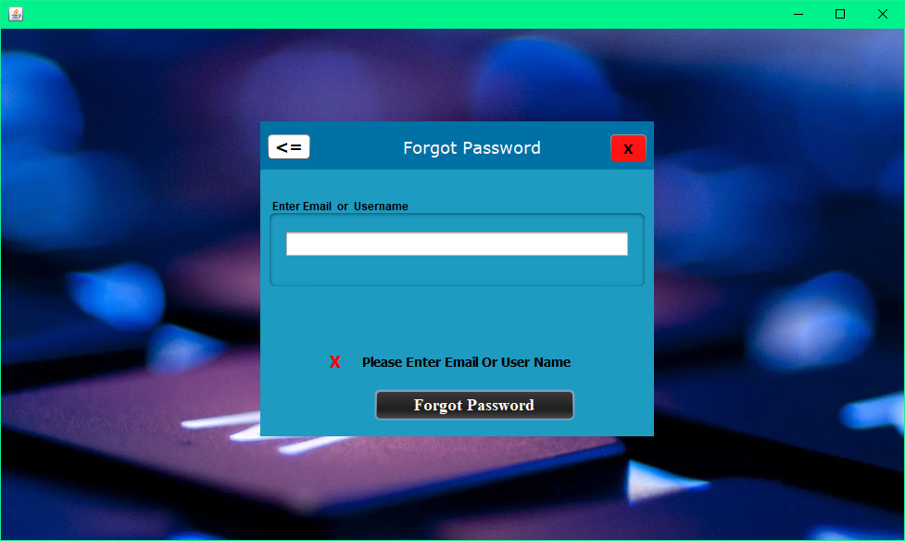

**Hire Employee** (Muhammad Umer Mukhtiar SP20-BSE-055)

**Scope:-** Job Portal App

**Level:-** User Goal

**Primary Actor:-** Employer

**Stakeholders and Interest:-**

-**Employer**:-hire employee for required work.

**Preconditions:-**enter required skill name in search bar.

**Success Scenario(Flow of events):-**

User Login

Greet with Dashboard.

Go to Menu

Enter skill in search bar

Click on search button

Click on employee name

Profile previewed

Click on Hire button

Dialog box appeared with message “request forwarded successfully”.

**Extensions(Alternative flows):-**

If no result found against skill dialog box appeared with message of no result found

**Success Guaranteed(Post):**- show all employees according to search or relevant skill.

**Special Requirements:-**

* Labels
* Buttons
* Dialog box
* Frames.

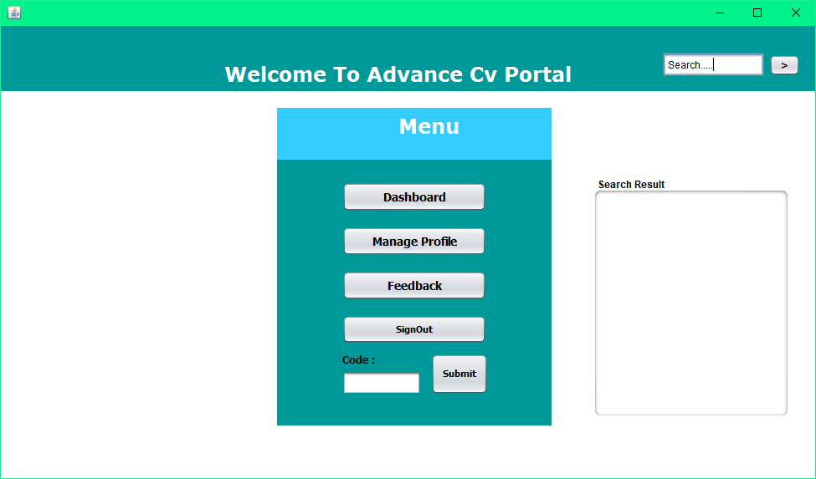

**1.Upload Document(Usman Taufique)**

**Scope:-** Job Portal App

**Level:-** User Goal

**Primary Actor:-** Candidate

**Stakeholders and Interest:-**

**-**Admin:- wants the documents to approve the profile and level up.

-Employer:- Needs to see the work and achievement of candidate to hire.

-App:- Application requires the educational data in documents to approve the profile to register

**Preconditions:-** Browse for document. Candidate will be required to upload the document in order to maintain a public profile.

**Success Guaranteed(Post):**- Document published to share with Employers or Anyone with share code.

**Main Success Scenario(Flow of events):-**

1. User Logins
2. System Greets with dashboard
3. User selects the documents section
4. Click Upload Button
5. Upload Dialog appears
6. Selects Docx Files
7. Upload file or can select multiples
8. File is Uploaded and shown in documents section

**Extensions(Alternative flows):-**

1. In case User selects the file of other format than .docx or pdf file the system rejects the file and file is not uploaded.
2. User has to publish the document after uploading to profile to make it visible to the person reviewing the file.
3. If User cancel the upload it goes back to the Document section.

**Special Requirements:-**

-Docx or pdf file Requires

-File size not be greater than 2mb

-Documents needed with educational information and work experiences in file forms.

**2.Generate Code(Usman Taufique)**

**Scope:-Job Portal App**

**Level:- User Goal**

**Primary Actor:- Candidate**

**Stakeholders and interests:-**

-**Candidate**:- To share his work to public share code is needed

-**Employer**:- To hire someone and review profile the code is required to enter.

**Precondition:-** Someone want to see your data you just click on generate code and send generated link to person or company who wants .

**Success Guarantee(Post):**- Employers are able to see Candidates work experience and Profile.

**Main Success Scenario(Flow of Events):-**

1. User logins
2. User Clicks the share code button on dashboard.
3. Code is generated as password to cloud
4. Code copy option is visible
5. User sends the Code to employer
6. Employer can use the Code to review profile or Hire.
7. Code is expired after 2 mins of generation.

**Extensions(Alternative Flow):-**

1. Code not opened in 2 mins it expires and shows nothing on click.
2. Code cannot be opened more than one time for one employer.
3. If Employer does not open link it expires
4. New link is generated and old is destroyed if user generates a new one.

**Special Requirements:-**

-Code must be generated and then copied too in 2 mins.

-Copied Code should be a small URL.

-Two generated Code cannot be same.

-Employer gets only viewing access to profile by Code

**Operation Contracts for Share Code**

|  |  |
| --- | --- |
| Contract 01 | CodeGenerating |
| operation | **GenerateCode()** |
| Cross Reference | **Use Case: Share Code** |
| Pre-Condition | **Profile is assigned a Unique Code** |
| Post Condition | * **Code stored with profile was displayed in textfield** * **New Code for profile was created in system** |

|  |  |
| --- | --- |
| Contract 02 | SharingCode |
| operation | **Copyfunc(RandomCode)** |
| Cross Reference | **Use Case: Share Code** |
| Pre-Condition | **Code is displayed in textfield.** |
| Post Condition | * **The User code was transferred to clipboard locally to share.** * **New Code was given to profile.** |

**SSD(ShareCode):-**

**Communication Diagram(ShareCode):-**

**Sequence Diagram(ShareCode):-**

**3.Upload Videos(Media):**

**Scope:-Job Portal App**

**Level:- User Goal**

**Primary Actor:- Candidate**

**Stakeholders and interests:-**

-Candidate:- To share links to work videos on cloud storage or streaming platform.

-Employer:- Making a good review of employers work the video is required to post good feedback.

**Precondition:-** Candidate login to the portal and makes his profile more unique and attracting by giving links to the videos of work he/she has done or experienced.

**Success Guarantee(Post):**- A Video Link is shared on User profile with Video Name.

**Main Success Scenario(Flow of Events):-**

1. User logins
2. User Clicks the Videos Section button on dashboard.
3. Videos list with links appears on App.
4. Links are clickable and clicked by user to review.
5. Candidate can upload new ones with upload button at bottom.
6. Clicking upload button brings up the dialog box with text to enter link to video.
7. After saving the link is available on Videos section of Dashboard.

**Special Requirements:-**

-Video link must be a link to only video.

-Copied Link should be a small URL.

-Cannot upload Videos Directly to App.

-Employer gets only viewing access to videos.

**4.View Profile:**

**Scope:-Job Portal App**

**Level:- User Goal**

**Primary Actor:- Employer**

**Stakeholders and interests:-**

-Employers- Wants to hire someone for work and company then wants to search or view profile or that candidate on app.

**Precondition:-** Employer needs a share code given by candidate or employee to paste in the share code field.

**Success Guarantee(Post):**- Employer enters the share code and the candidates profile with name appears to be clicked on and after clicking it opens the profile with details about candidate on app.

**Main Success Scenario(Flow of Events):-**

Employer Copies the share code from candidate.

Opens the share code entering section.

Paste the share code and enter

Employer has viewing access to the relevant profile to share code.

**Special Requirements:-**

-Profile must be completed before sharing.

-Profile can only be shared when information is fully registered.

-User cannot make two profiles with same account.

-Employer can only view the profile.

**1.** **GIVING FEEDBACK (NOOR AHMED)**

**Scope:-** Job Portal App

**Level:-** User Goal

**Primary Actor:-** EMPLOYEE

**Stakeholders and Interest:-**

**-**Admin:- will check the feedback and approve it

-Employer: - need to give feedback for user profile

-App: - Application requires the educational data in documents to approve the profile to register

**Preconditions: -** Give the feedback

**Success Guaranteed (Post):**- after giving the feedback if the section says feedback is uploaded successfully uploaded.

**Main Success Scenario (Flow of events):-**

1. Employer open feedback section
2. Feedback section will appear
3. Employer will rate the skills
4. Give feedback in dialog box
5. Submit the feedback
6. Admin will approve the feedback
7. Feedback will be visible

**Extensions (Alternative flows):-**

1. In case if employer will use the abusive language, the feedback will automatically be rejected
2. Employer have to wait till the admin will approve the feedback
3. If employer cancel the feedback it will not visible to any one

**Special Requirements: -**

-Feedback must be given by employee

-feedback should be in the limited words

**2.REPORT PROFILE (NOOR AHMED)**

**Scope: -Job Portal App**

**Level: - User Goal**

**Primary Actor: - Employer**

**Stakeholders and interests: -**

**Candidate**: - To share his work to public link is needed

**-Employer**: - report the fake profile or the fake user

**Precondition: -** employer must have dispute to report the profile

**Success Guarantee (Post):** - after the report will be review by the admin account will be terminated

**Main Success Scenario (Flow of Events): -**

1. Report profile
2. Click the report button
3. Dialog box will be appeared
4. Report the profile by different conditions
5. Then submitted the report
6. After the report. admin will approve it

**Extensions (Alternative Flow): -**

1. If once report is submitted it cannot be changed
2. If the report if wrong your profile will be terminated

**GIVING PROFILE FEEDBACK (NOOR AHMED)**

**Scope:-** Job Portal App

**Level:-** User Goal

**Primary Actor:-** EMPLOYEE

**Stakeholders and Interest:-**

**-**Admin:- will check the feedback and approve it

-Employer: - need to give feedback for user profile

-App: - Application requires the educational data in documents to approve the profile to register

**Preconditions: -** Give the profile feedback

**Success Guaranteed (Post):**- after giving the feedback if the section says profile feedback is uploaded successfully uploaded.

**Main Success Scenario (Flow of events):-**

1. Employer open feedback section
2. Open the sub section of profile feedback
3. Profile Feedback section will appear
4. Give profile feedback in dialog box
5. Submit the profile feedback
6. Admin will approve the feedback
7. Feedback will be visible

**Extensions (Alternative flows):-**

1. In case if employer will use the abusive language, the profile feedback will automatically be rejected
2. Employer have to wait till the admin will approve the feedback or it passes through the filter
3. If employer cancel the feedback it will not visible to any one

**Special Requirements: -**

Profile Feedback must be given by employee

Profile feedback should be in the limited words

**--------------------------------------------------**

**Operation Contracts(SP20-BSE-055)**

2021

* **Operation Contract for Login**

|  |  |
| --- | --- |
| Contract Id | Login |
| operation | **User Login(Username,email,Password)** |
| Cross Reference | **Login** |
| Pre-Condition | **Enter User email and Password** |
| Post Condition | * **Validate Credentials ValidateCredentials(username, pass)** * **Verify Details from Local Database** * **Return true;** |

* **Operation Contracts for Signup**

|  |  |
| --- | --- |
| Contract Id | Enterdetails |
| operation | Enterdetails(Name,email,password..) |
| Cross Reference | **Signup** |
| Pre-Condition | * **Signup Form Generated.** * **Enter required details** |
| Post Condition | * **Save information from text fields** * **Validate information.** |

|  |  |
| --- | --- |
| Contract Id | TermsAndConditions |
| operation | AcceptTermsAndConditions |
| Cross Reference | **Signup** |
| Pre-Condition | **Accept Terms and Conditions** |
| Post Condition | * **Terms And Conditions Accepted** * **Check button get true value.** * **Allow user to forward request .** |

|  |  |
| --- | --- |
| Contract Id | Signup |
| operation | Click On Signup |
| Cross Reference | **Signup** |
| Pre-Condition | **Click on Signup to Create Account** |
| Post Condition | * **Validate Details** * **Check Empty text fields** * **Save details Against user.** * **Accept request to create Account .** |

* **Operation Contracts for Forgot**

|  |  |
| --- | --- |
| Contract Id | EnterEmail |
| operation | Enter Email or User name |
| Cross Reference | **Forgot** |
| Pre-Condition | **Enter Email or User Name to forgot Password** |
| Post Condition | * **Validate Details** * **Check Empty text fields** * **Display Question .** |

|  |  |
| --- | --- |
| Contract Id | AnswerSecuirtyQuestion |
| operation | Answer Security Question(Answer) |
| Cross Reference | **Forgot** |
| Pre-Condition | **Answer a Security Question** |
| Post Condition | * **Validate Answer.** * **Check Empty text fields** * **Request Accepted.** * **Linked to Set Profile At Change Password Section.** |

* **Operation Contract for Set Profile**

|  |  |
| --- | --- |
| Contract Id | EnterDetails |
| operation | **EnterDetails(Name,Education…)** |
| Cross Reference | **Set Profile** |
| Pre-Condition | **Add information in required Text Fields** |
| Post Condition | * **Validate Details** * **Save against profile** |

|  |  |
| --- | --- |
| Contract Id | SaveChanges |
| operation | **SaveChanges()** |
| Cross Reference | **Set Profile** |
| Pre-Condition | **Click on Save Changes** |
| Post Condition | * **Validate Details** * **Save against profile** * **Replace old info with new.** |

|  |  |
| --- | --- |
| Contract Id | UploadProfilePic |
| operation | **UploadProfilePic ()** |
| Cross Reference | **Set Profile** |
| Pre-Condition | **Upload profile Picture** |
| Post Condition | * **Saved Against Profile** * **Remove old Profile pic** * **set according to frame size** * **available for public .** |

* **Operation Contract for Hire Employee**

|  |  |
| --- | --- |
| Contract Id | SearchSkill |
| operation | **Search required Skill** |
| Cross Reference | **Hire Employee** |
| Pre-Condition | **Search Employee for required work** |
| Post Condition | * **Search in category.** * **Show user profiles.** * **Show relevant Profiles.** |

|  |  |
| --- | --- |
| Contract Id | HireEmployee |
| operation | **HireEmployee** |
| Cross Reference | **Hire Employee** |
| Pre-Condition | **Select Employee from given profiles.** |
| Post Condition | * **Request forward for Share Full Profile** * **Limited profile previewed.** |

**Operation Contracts(SP20-BSE-046)**

**Operation Contracts for Upload Document**

|  |  |
| --- | --- |
| Contract 01 | OpenDocumentSection |
| operation | **OpenDocuments(List)** |
| Cross Reference | **Use Case :Upload Documents** |
| Pre-Condition | **Documents Storage is being edited.** |
| Post Condition | * **Existing Documents are ready to be viewed.** * **Space made for new document Upload.** |

|  |  |
| --- | --- |
| Contract 02 | InitializingUpload |
| operation | **InitiateUpload(Document)** |
| Cross Reference | **Use Case :Upload Documents** |
| Pre-Condition | **Space available for uploading new files coming from user.** |
| Post Condition | * **Validity of file format was checked.** * **Empty space in cloud was created for document.** |

|  |  |
| --- | --- |
| Contract 03 | FileUpload |
| operation | **SelectFile(Docx,PDF)** |
| Cross Reference | **Use case : Upload Documents** |
| Pre-Condition | **Cloud is ready for file to be uploaded.** |
| Post Condition | * **File was docx or pdf file.** * **File became a document with name in list.** * **File was made visible to user on profile and data.** |

**Operation Contract for Share Videos**

|  |  |
| --- | --- |
| Contract 01 | VideoSection |
| operation | **OpenVideos(Links)** |
| Cross Reference | **Use Case : Share Videos** |
| Pre-Condition | **Logged in to Portal with Account** |
| Post Condition | * **List of Video Links was displayed** * **URLs were shown as hyperlinks in section** |

|  |  |
| --- | --- |
| Contract 02 | LinktoVideo |
| operation | **ShareLink(URLtoVideo)** |
| Cross Reference | **Use Case : Share Videos** |
| Pre-Condition | **Video is uploaded on Streaming Site** |
| Post Condition | * **Video was playing in site without errors.** * **Viewing rights were with the uploader** |

|  |  |
| --- | --- |
| Contract 03 | PasteLink |
| operation | **enterLink(StreamSite)** |
| Cross Reference | **Use Case : Share Videos** |
| Pre-Condition | **Platform is valid for viewing Video** |
| Post Condition | * **Video is embedded on portal with viewing rights** * **Video was generated as link into system** * **Link was made object to click and open.** |

**Operation Contracts for Generate Code**

|  |  |
| --- | --- |
| Contract 01 | CodeGenerating |
| operation | **GenerateCode()** |
| Cross Reference | **Use Case: Share Code** |
| Pre-Condition | **Profile is assigned a Unique Code** |
| Post Condition | * **Code stored with profile was displayed in textfield** * **New Code for profile was created in system** |

|  |  |
| --- | --- |
| Contract 02 | SharingCode |
| operation | **ShareCodeCopy(RandomCode)** |
| Cross Reference | **Use Case: Share Code** |
| Pre-Condition | **Code is displayed in textfield.** |
| Post Condition | * **The User code was transferred to clipboard locally to share.** * **New Code was given to profile.** |

**Operation Contracts for ViewProfile**

|  |  |
| --- | --- |
| Contract 01 | RequireCode |
| operation | **enterCode(ShareCode)** |
| Cross Reference | **Use Case: View Profile** |
| Pre-Condition | **Employer has Code from Candidate.** |
| Post Condition | * **Code was entered into search attribute.** * **Profile binded with code is shown as list.** |

|  |  |
| --- | --- |
| Contract 01 | ViewProfile |
| operation | **ViewProfile(CandidateAcc)** |
| Cross Reference | **Use Case: View Profile** |
| Pre-Condition | **Share code is matched with a profile.** |
| Post Condition | * **The Profile was displayed on display for employer view.** |